

THE HERITAGE

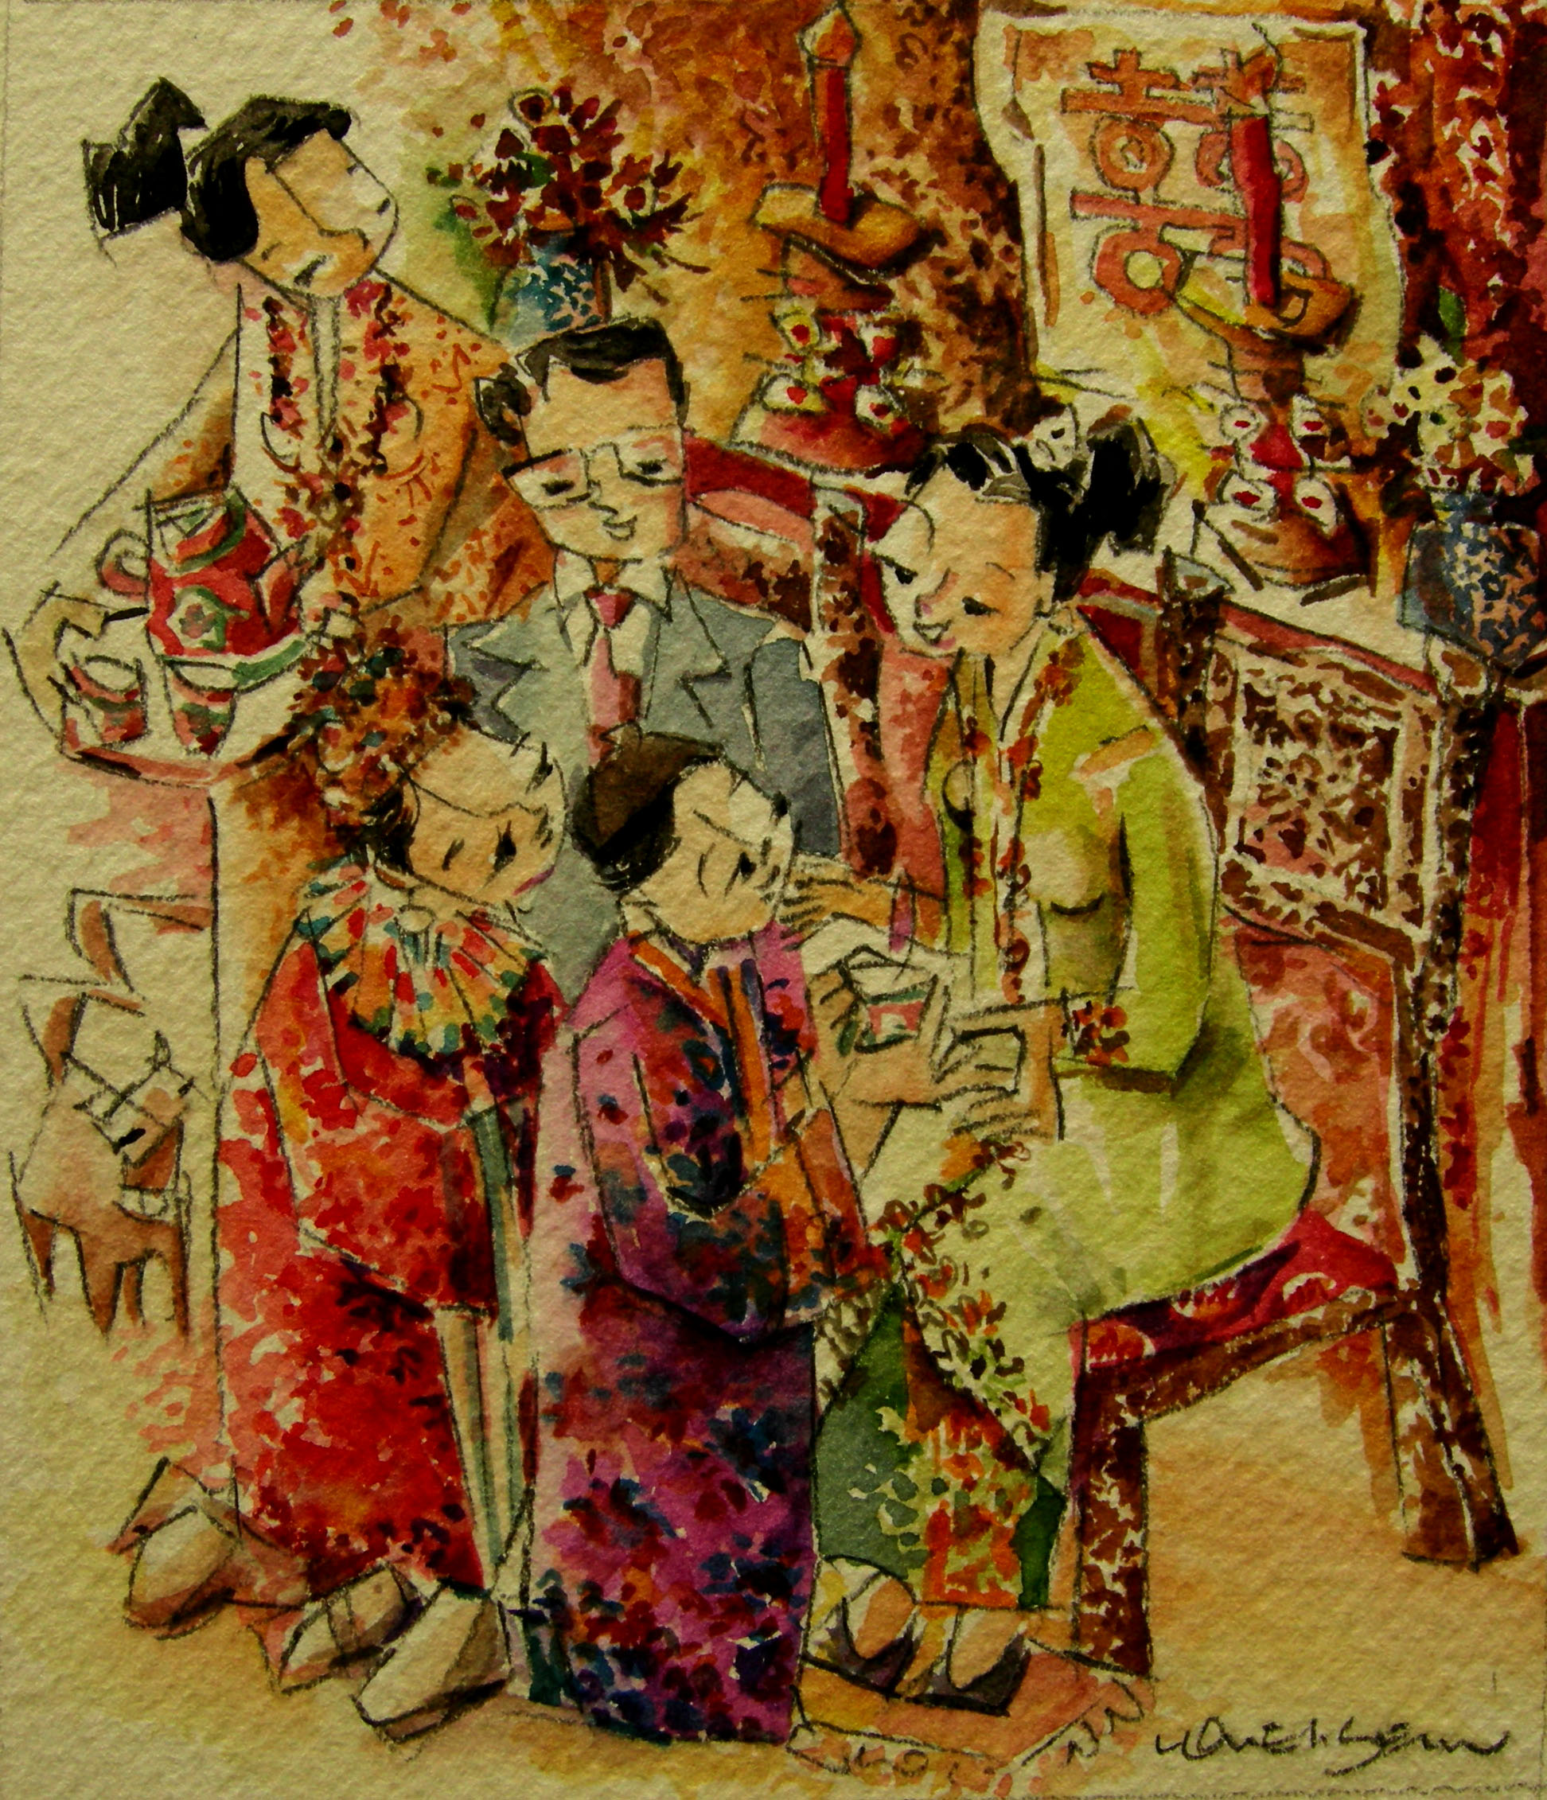
Tea Ceremony
During the tea ceremony, the couple kneels before their elders serving tea in order starting from the elders.

